EADA MEMBERSHIP FORM 2021
Please complete this form and send it to the Membership Secretary below with an SAE and cheque payable to EADA Ltd. or complete a Bank Transfer to the EADA account.
BACs details are:-Account name: EADA Ltd
Bank:-HSBC 62 George White St,Cabot Circus,Bristol,BS13BA.Sort Code:-40-14-13, Acc No 82351900
Membership Secretary:- Jack Gibson. 11 Church Road,Thornbury, Bristol, BS35 1EJ
Annual cost for EADA membership £10.0 per person for all ages, per annum.10 year membership can be purchased for £90.0. New members should include a photocopy of their passport showing date of birth.
For information regarding EADA, email tony_clipstone@btinternet.com
For FAQ and Application forms also see website www.eada.co.uk
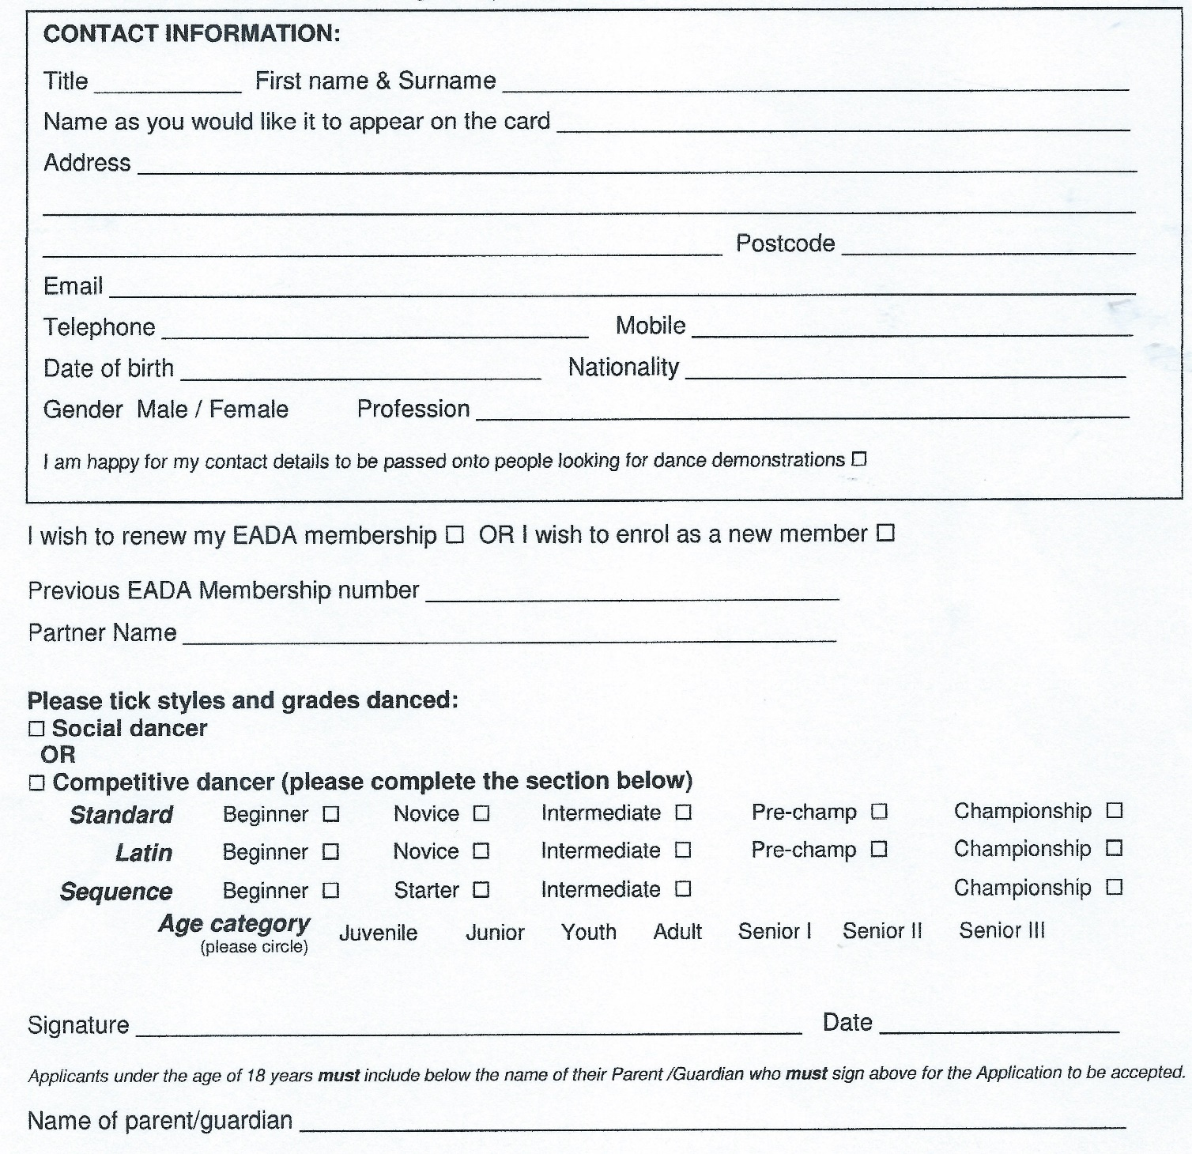
Please allow 14 days for membership to be processed. EADA currently complies with the relevant sections of the GDPR 2018, and will continue to do so. By using and signing the membership form you agree that EADA will securely hold the data included on the form. Our Privacy Notice is available to view on the website.

